PSD to HTML instructions

**Pop-up boxes** – these will need to pop-up when the user hovers over the (!) and ‘WHY?’ icons below.

1.   
   This box will have a static message similar to the one you see here.

1.   
   When the user hovers over ‘WHY?’, a pop-up similar to the one it item 1) will need to appear. This one however will need to be dynamic in order to fit text of different size. The text will range between this:
   1. Short example:
      * Correlation with other fake reviewers' profile data and language.
   2. Long example:
      * Overwhelming amount of positive reviews
      * Large amount of reviews for same seller
      * Correlation with other fake reviewers' profile data and language.
      * Reviewer marked as unhelpful by amazon users
      * Large number of reviews created on the same date.
      * User data shows account was likely created for single review

**Stars** – the stars need to be adjustable to show any value from 0.0 to 5.0, including fractions. For example if the result is 3.7, the stars need to show 3.7 stars colored in.

 and 

**Font** - one of the main fonts used in the design is called ‘Montserrat’. I have attached it for you to use. The other fonts are standard windows fonts.

**Landing Page to Product Page transition animation** – Once the user enters a URL and presses Analyze on the the Landing Page, the Landing page needs to transition into the Product Page with the orange part sliding downwards to reveal the Product Page information.

From this to this 🡪  
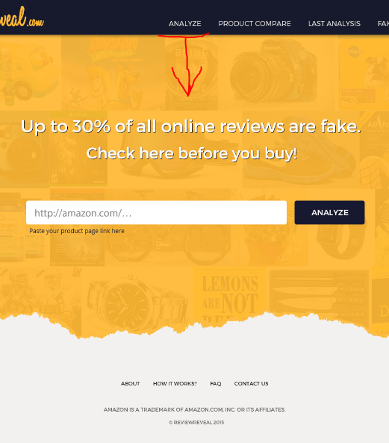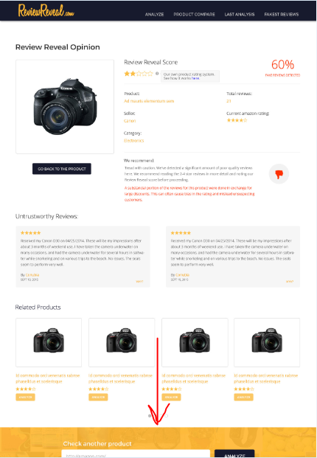

**Related Products Progression** ­– The related products will be shown 4 at a time (on desktop) and the user should be able to slide through them by using the circles below the products here:

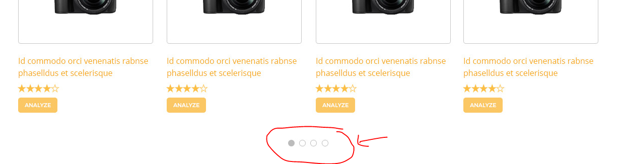

When the user presses the next button, the next 4 items need to appear.

**Progress Bar** – The progress bar needs to be very similar to the one below and also needs to have space for similar status update text. The progress bar should be similar, but larger than this one and colored orange, similar to the design.

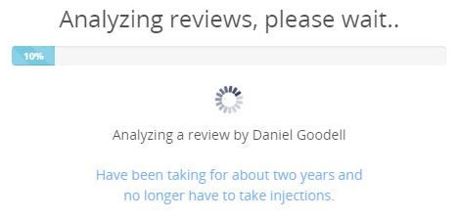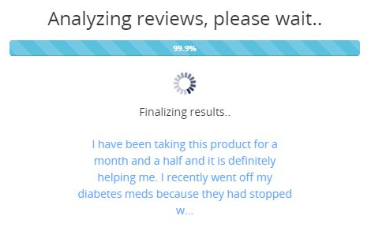

The progress bar needs to be located here and will be replaced by the recommendation text once it loads:

